WHAT’S THE BIG DEAL ABOUT PROTEIN???

- Protein is important to keeping your muscles strong so that you can stay active and healthy!
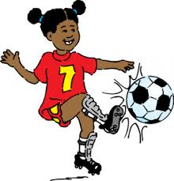

- Protein provides us with the energy needed to learn and play, and helps us feel full after eating!
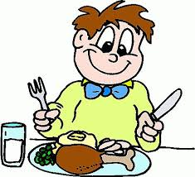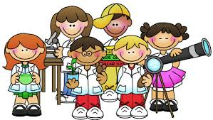

- Protein is found in foods such as chicken, pork, tofu, eggs, beans, fish, beef, and lentils!
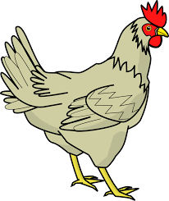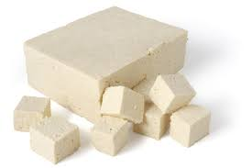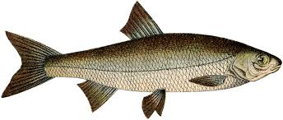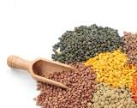
Chicken is the most commonly eaten poultry (bird) in the world.
Tofu is made by coagulating (changing from liquid to solid) soy milk until it forms a solid block.It is common Asian cuisine.
Popular types of fish include mackerel, salmon, catfish, cod, and tuna.
Lentils are legumes that first appeared in central Asia. They come in a variety of colors such as red, yellow, brown, and black.

